1.write a map function which calculate salary on the basis on number of hours of working (hrs,perhrpay)

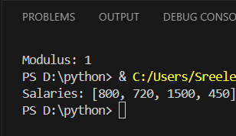work_data = [(8, 100), (6, 120), (10, 150), (5, 90)]

def calc_salary(item):

hrs, rate = item

return hrs * rate

salaries = list(map(calc_salary, work_data))

print("Salaries:", salaries)

2.write a map function to calculate division as per the obtained marks

marks_list = [85, 73, 59, 45, 33, 90, 50, 27]

def get_division(marks):

    if marks >= 60:

        return "First Division"

    elif marks >= 50:

        return "Second Division"

    elif marks >= 35:

        return "Third Division"

    else:

        return "Fail"

divisions = list(map(get_division, marks_list))

print("Divisions:", divisions)

3.create functyions for arithmetic operators like sum function for adding 3 nums, diff, mult, div, mods

4. create a class shareholder have 5 data members and 3 functions 1 constructor in class, create 2 objects and use datamembers and functions of class